**TABLE**

|  |  |  |
| --- | --- | --- |
| Sl.No | Contents | Page.No |
| 1 | Abstract | 1 |
| 2 | Introduction | 2 -3 |
| 3 | Objectives | 4 |
| 4 | Methodology | 5-9 |
| 5 | Functional Requirements | 10 |
| 6 | Literature Survey | 11-12 |
| 7 | E.R Diagram | 13 |
| 8 | Scope | 14-15 |
| 9 | Problem Definition | 16-17 |
| 11 | Results | 18-24 |
| 12 | Activity Diagram | 25-26 |
| 13 | Conclusion | 27 |

# 

# 

# ABSTRACT

This abstract introduces a comprehensive web application designed to address the pressing issue of food waste reduction. The application serves as an interactive platform for individuals, businesses, and organizations to actively participate in minimizing food waste by providing innovative solutions and facilitating behavior change. Leveraging the power of technology, the web application aims to raise awareness, promote responsible consumption, and connect users with resources and tools to reduce food waste at various stages of the food lifecycle. By empowering users with knowledge, practical tips, and data-driven insights, the application encourages informed decision-making and collaboration, ultimately contributing to a more sustainable and efficient food system.

Food waste is a global problem with significant environmental, economic, and social consequences. To combat this issue, a web application has been developed to empower individuals and businesses to take an active role in reducing food waste. This application harnesses the capabilities of technology to engage users, foster collaboration, and provide practical solutions to address the challenges associated with food waste

# INTRODUCTION

Food waste management systems are vital for addressing the global issue of food waste, which refers to the disposal or wastage of edible food that could have been consumed. These systems aim to reduce, reuse, and recycle food waste in order to minimize its environmental, economic, and social impacts.

Here is a brief introduction to the key elements of such a system:

**Prevention:** The first step in food waste management is prevention. This involves raising awareness about the issue, promoting responsible consumer behavior, and encouraging efficient practices throughout the supply chain. By reducing food waste at the source, prevention is the most effective strategy in the system.

**Recovery:** Food recovery involves collecting surplus or unsold food from various sources such as restaurants, supermarkets, and farms, and redirecting it to people in need. This can be done through food banks, charitable organizations, or innovative initiatives that connect donors with recipients.

**Redistribution:** Redistribution focuses on diverting excess food that cannot be used to feed people to other purposes, such as animal feed, composting, or energy generation. By ensuring that food waste is utilized in alternative ways, this step maximizes resource efficiency and minimizes environmental impact.

**Recycling:** When food waste cannot be used for human consumption or animal feed, it can be converted into valuable resources through recycling. This can involve processes like anaerobic digestion, which produces biogas and organic fertilizers, or composting, which transforms organic waste into nutrient-rich soil amendments.

**Monitoring and Data Analysis**: Implementing an effective food waste management system requires comprehensive monitoring and data analysis. By tracking and analyzing food waste generation, disposal patterns, and the effectiveness of various interventions, stakeholders can make informed decisions, identify areas for improvement, and optimize resource allocation.

**Policy and Regulation:** Governments and regulatory bodies play a crucial role in establishing policies and regulations that support food waste reduction and management. These can include incentives for businesses to adopt waste reduction practices, guidelines for food donation and safety, or mandates for reporting and monitoring food waste.

By integrating these components into a comprehensive framework, a food waste management system can effectively address the challenges associated with food waste, including environmental degradation, resource depletion, and social inequality. Such systems have the potential to promote sustainability, reduce hunger, and create a more efficient and equitable food system for the benefit of both present and future generations.

# OBJECTIVES

The Food Waste Reduction Web Application aims to empower individuals, businesses, and communities to actively participate in reducing food waste, fostering a more sustainable and responsible approach to food consumption and waste management. Here are some specific objectives:

* **Raise Awareness:** The web application aims to educate users about the magnitude and impact of food waste. By providing information on the environmental, social, and economic consequences of food waste, the application raises awareness and promotes a sense of urgency around the issue.

* **Encourage Responsible Consumption:** The web application seeks to promote responsible consumption habits among individuals and businesses. It provides practical tips, guidelines, and resources to help users make informed decisions about food purchasing, storage, and preparation, thereby minimizing waste at the consumer level.

* **Provide Practical Tools and Resources:** The application offers a variety of tools, resources, and interactive features to assist users in reducing food waste. These include meal preparde time, Quantity of Food and storage tips to help users optimize their food usage and minimize waste.

* **Foster Collaboration and Engagement**: The application fosters a sense of community and collaboration by connecting users who are passionate about reducing food waste. It provides forums, discussion boards, and social features to facilitate knowledge sharing, idea exchange, and the formation of partnerships to collectively address the issue.

* **Facilitate Food Redistribution:** The web application serves as a platform to connect food donors with recipients, such as charitable organizations. It streamlines the process of food donation and redistribution, ensuring that surplus edible food is redirected to those in need.

**METHODOLOGY**

# Front End Technologies

1. CSS3, which stands for Cascading Style Sheets 3, is the latest version of the CSS specification used for styling and formatting the visual presentation of HTML documents. It builds upon the previous versions of CSS, introducing new features, enhancements, and capabilities to provide more flexibility and control over the appearance of web pages.

Here are some key features and improvements introduced in CSS3:

* Transforms and 2D/3D Effects
* Flexible Box Layout (Flexbox)
* Box Model Enhancements
* Selectors

2. JavaScript is a high-level, interpreted programming language that is primarily used for adding interactivity and dynamic behavior to web pages. It is supported by all modern web browsers and can be executed on both the client-side (in the browser) and the server-side (with the help of server-side frameworks like Node.js).

Here are some key aspects and features of JavaScript:

* Libraries and Frameworks
* Event Handling
* Data Types and Operations
* Syntax and Structure
* Client-Side Scripting

3. React is a JavaScript library for building user interfaces. It is used to build singlepage applications (SPAs). React is declarative, meaning that you describe what your UI should look like, and React will figure out how to render it. This makes your code more predictable and easier to debug.

React is also efficient, meaning that it only updates the parts of your UI that need to be updated when your data changes. This makes your app feel more responsive.

React is a popular library, and there are a lot of resources available to help you learn it. If you're interested in building SPAs, React is a great option.

**Npm Packages Used**

* Express
* Ejs
* Express-ejs-layouts
* Mongoose
* Express-session
* Bcryptjs
* Passport
* Passport-local
* Connect-flash
* Method-override
* Dotenv
* Nodemailer
* Randomstring 14. stripe

# Back-End Technologies

MongoDB is a popular NoSQL (non-relational) database management system that provides a flexible and scalable approach to storing and managing data. MongoDB is well-suited for applications that require flexible data modeling, scalability, and high performance. Its document-oriented approach, scalability features, and rich querying capabilities make it a popular choice for a wide range of use cases, including content management systems, real-time analytics, e-commerce, and mobile applications.

Here are some key aspects and features of MongoDB:

Scalability and Performance

Flexible Data Model

* Rich Query Language
* Replication and High Availability
* Flexible Data Consistency

2. Node.js is an open-source, server-side JavaScript runtime environment that allows developers to build scalable and high-performance web applications. Unlike traditional JavaScript, which runs in the browser, Node.js enables JavaScript to be executed on the server, making it possible to create server-side applications using JavaScript.

Here are some key aspects and features of Node.js:

* JavaScript on the Server
* Scalability and Performance
* Extensive Module Library
* Cross-Platform Compatibility
* Microservices and Backend API
* Server-Side Web Development

3. Express.js is a fast and minimalist web application framework for Node.js. It provides a set of robust features and tools for building web applications and APIs quickly and efficiently. Express.js is known for its simplicity, flexibility, and ease of use, making it a popular choice among developers.

Here are some key aspects and features of Express.js:

* Web Application Framework
* Error Handling
* Static File Serving
* Templating
* Middleware
* Routing

# FUNCTIONAL REQUIREMENTS

1.4.1 Use Case Diagram

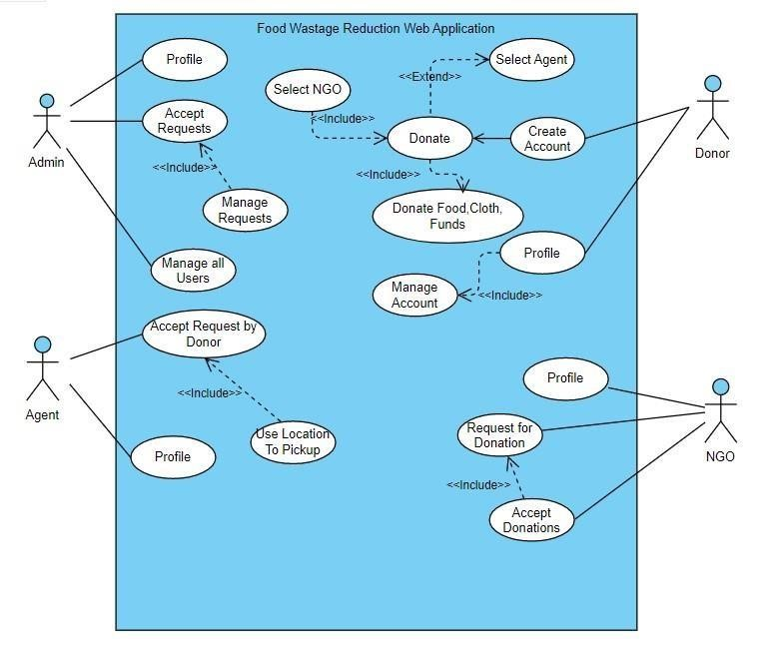

**Figure 1.4.1. Use Case Diagram**

# E.R Diagram

**LITERATURE SURVEY**

A literature survey on food waste reduction web applications reveals a growing body of research and studies focusing on this topic. The use of web applications in food waste reduction has been explored, emphasizing their potential to raise awareness, facilitate behavior change, and provide practical tools for managing food waste. The integration of technologies in smart bins and the utilization of web applications for data analysis and waste management have also been discussed. Designing user-centered web applications that understand user needs, preferences, and challenges is highlighted as crucial for effective waste reduction solutions. Existing food waste reduction apps have been reviewed, with an emphasis on features such as recipe suggestions, shopping lists, and waste tracking, along with potential improvements in user engagement, personalization, and social sharing. In the hospitality sector, web-based tools have been examined, focusing on waste tracking, inventory management, and donation coordination. Studies evaluating the effectiveness of food waste reduction web applications indicate the impact on user satisfaction, perceived usefulness, and behavior change. Overall, the literature survey emphasizes the importance of user-centered design, real-time monitoring, collaboration, and data management in developing effective web applications for food waste reduction.

1. The Use of Mobile Applications in Food Waste Reduction by Boksun Kim, et al. (2019): This study explores the use of mobile applications in reducing food waste. It discusses the potential of mobile apps to raise awareness, facilitate behavior change, and provide practical tools for managing food waste. The research highlights the importance of user-centered design and emphasizes the need for personalized features and real-time data tracking.

2. A Review of Food Waste Reduction Technologies: Smart Bins and Web

Applications by Zhiwei Ma, et al. (2018): This paper examines the role of smart bins and web applications in reducing food waste. It discusses the integration of sensor technologies in waste containers and the use of web applications for data analysis and waste management. The research emphasizes the benefits of realtime monitoring and analytics in improving waste reduction strategies.

3. Designing a Web Application for Food Waste Management: A User-Centered Approach by Anna F. Scafuri, et al. (2018): This study focuses on the design of a user-centered web application for food waste management. It discusses the importance of understanding user needs, preferences, and challenges in developing effective waste reduction solutions. The research emphasizes the role of user engagement, education, and behavior change techniques in promoting sustainable consumption practices.

4. Food Waste Reduction Apps: A Review of Existing Features and Potential Improvements by Sara Marzi, et al. (2020): This review paper examines existing food waste reduction apps and analyzes their features and functionalities. It identifies common features such as recipe suggestions, shopping lists, and waste tracking, and discusses potential improvements in terms of user engagement, personalization, and social sharing. The study provides insights into the design and features of successful food waste reduction applications

**E.R Diagram** 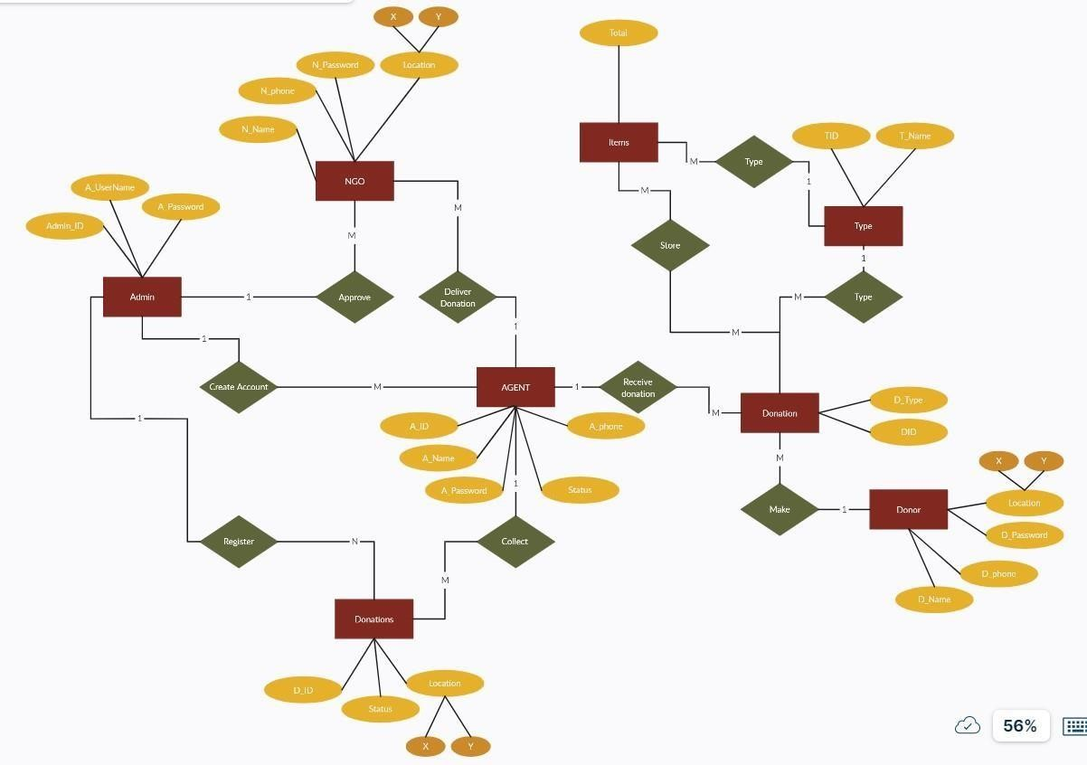

# SCOPE

While the initial development of the Food Wastage Reduction Web Application is a significant achievement, there are several avenues for future work and improvement:

* **Continuous Improvement of Content:** The application's educational content can be continuously updated and expanded to cover a wider range of topics related to food wastage reduction. Incorporating emerging research, best practices, and innovative solutions will ensure that users have access to the latest information and strategies.

* **Behavioral Insights and Personalization:** Utilizing behavioral insights and data analytics, the application can provide personalized recommendations and interventions tailored to individual users. By understanding users' behaviors and preferences, the application can deliver targeted messages and interventions that are more likely to drive behavior change.

* **Partnerships and Integration:** Collaborating with organizations, government agencies, and other stakeholders can enhance the application's impact. Partnerships can provide access to additional resources, expertise, and data that can enrich the user experience and extend the reach of the application.

* **Social Engagement and Community Building:** Expanding the social features of the application, such as discussion forums and community challenges, can foster engagement and create a sense of community among users. Encouraging users to share their experiences, success stories, and tips for reducing food wastage can inspire others and create a supportive environment.

* **Measurement and Evaluation:** Developing robust measurement and evaluation mechanisms can assess the application's effectiveness in reducing food wastage and promoting sustainable practices. Gathering feedback from users, conducting surveys, and tracking key metrics will provide valuable insights for continuous improvement and optimization.

* **Expansion to Mobile Platforms:** Creating a mobile application version of the web application can enhance accessibility and convenience for users. Mobile apps can leverage features such as push notifications, barcode scanning for food tracking, and location-based services to deliver a seamless user experience

# PROBLEM DEFINATON

To develop the system for Food Wastage Reduction Web Application to improve teaching and learning.

**Problem Approach :**

* **Problem:** Food waste is a major problem worldwide. According to the Food and Agriculture Organization of the United Nations, one-third of all food produced for human consumption is wasted every year. This waste has a significant environmental impact, as it contributes to greenhouse gas emissions and land degradation. It also has a negative impact on food security, as it means that less food is available for people who need it.

* **Approach:** A food wastage reduction web application could be developed to help address this problem. The application could be used by individual , restaurants, and other food service providers to track their food waste and identify areas where it can be reduced. The application could also provide resources and tips on how to reduce food waste.

* **Benefits:** A food wastage reduction web application could have a number of benefits, including:
* Reduced environmental impact: By reducing food waste, the application could help to reduce greenhouse gas emissions and land degradation.
* Improved food security: By making more food available, the application could help to improve food security.
* Increased teaching and learning: The application could be used to teach students about food waste and how to reduce it.
* Here are some specific features that could be included in a food wastage reduction web application:

* **Food waste tracking:** The application could allow users to track the amount of food waste they produce. This could be done by entering the type, quantity, and date of food waste.

* **Food analysis:** The application could analyze the data entered by users to identify areas where food is delivered. This could be done by looking at factors such as the type of food, the time of day, and the day of the week.

* **Educational resources:** The application could provide users with educational resources about food waste. These resources could include articles, Pictures and quotes.
* The development of a food wastage reduction web application could be a valuable tool for Marriage halls, restaurants, and other food service providers. The application could help to reduce food waste, improve food security, and increase teaching and learning.

# RESULTS

After thoroughly analyzing the problem and developing a Food Wastage Reduction Web Application using the problem approach outlined above, the expected result is a comprehensive and effective solution that addresses the needs of various stakeholders involved in the effort to reduce food wastage. The web application will serve as a valuable platform for promoting teaching and learning about the issue, fostering behavior change, and encouraging sustainable practices.

Through the application, users, including teachers and students, will gain a deeper understanding of the environmental, economic, and social impacts of food wastage. Educational content, interactive quizzes, and engaging resources will raise awareness and inspire users to take action.

The specific results of a food wastage reduction web application would depend on a number of factors, such as the design of the application, the target audience, and the level of user engagement. However, the potential benefits of such an application are significant and could make a real difference in the fight against food waste.

Overall, the result of developing and implementing the Food Wastage Reduction Web Application will be a positive and impactful contribution to teaching and learning. It will drive awareness, behavior change, and community collaboration, ultimately leading to a significant reduction in food wastage and a more sustainable future.

# Admin Dashboard

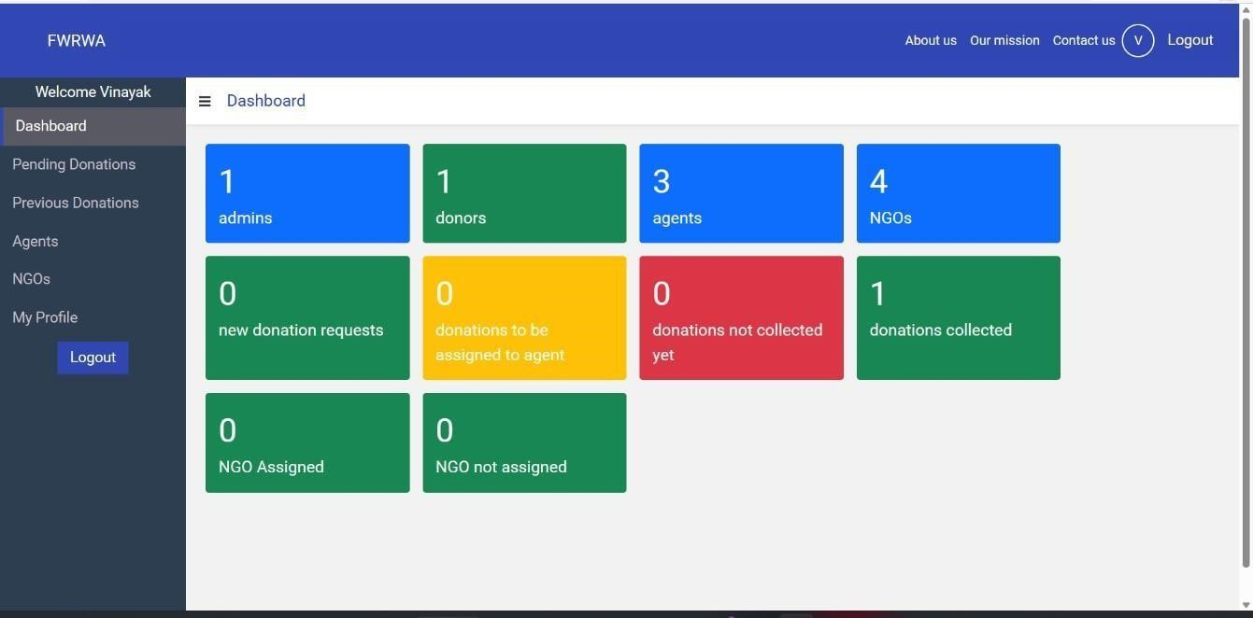

# Donor dashboard

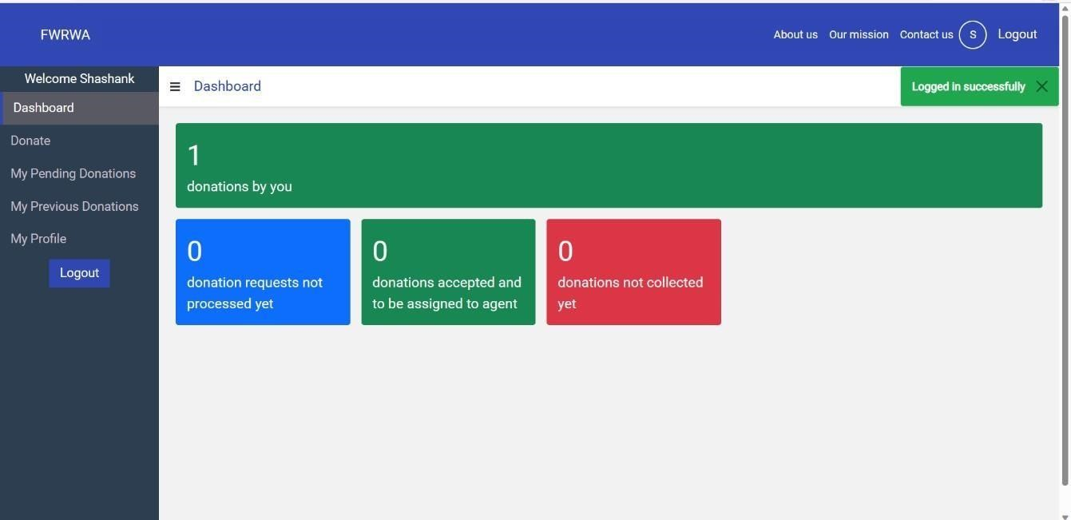

# NGO dashboard

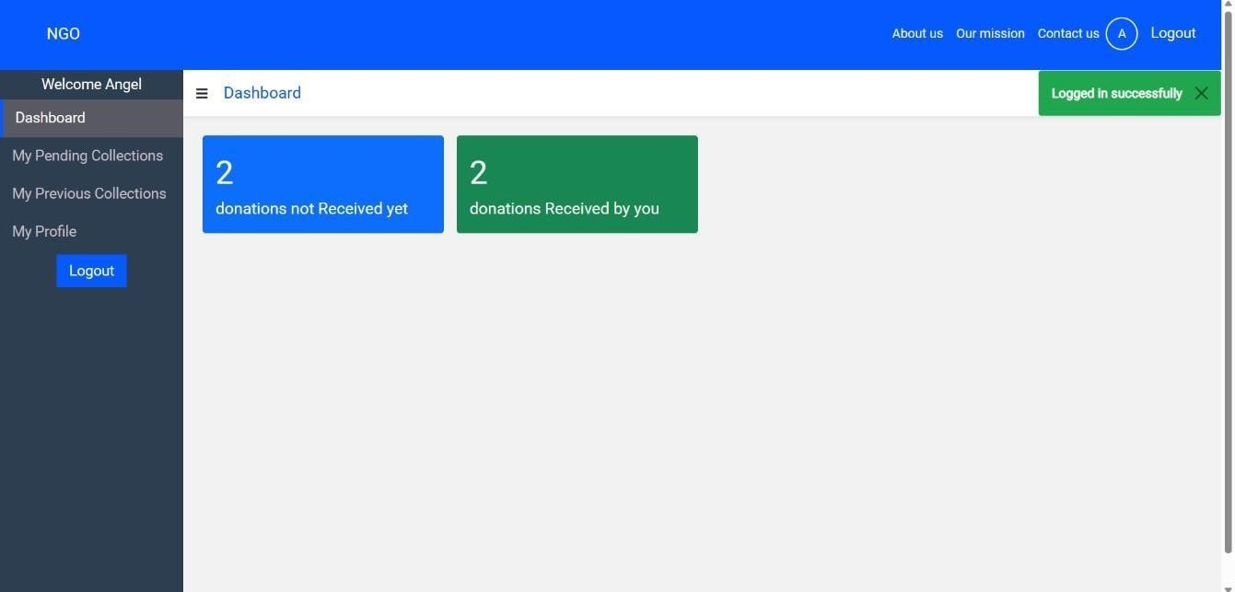

# Agent Dashboard

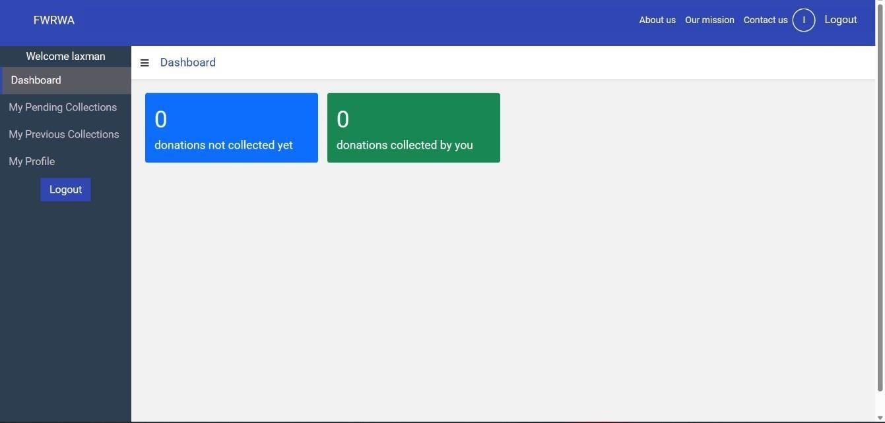

# Donor Donation Page

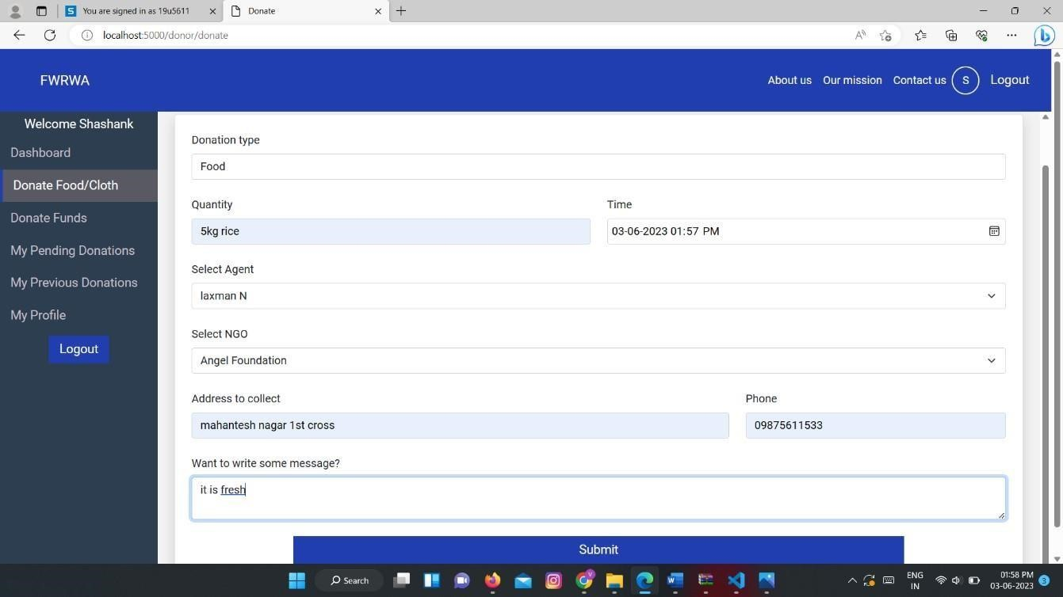

# Donor Fund Donate page

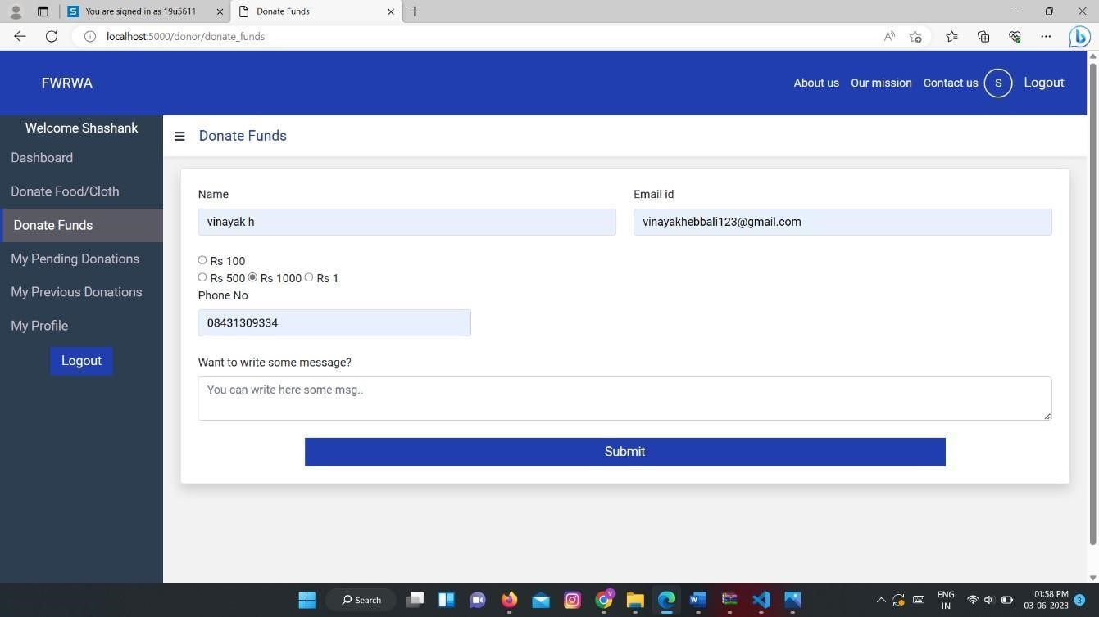

# Donation description page

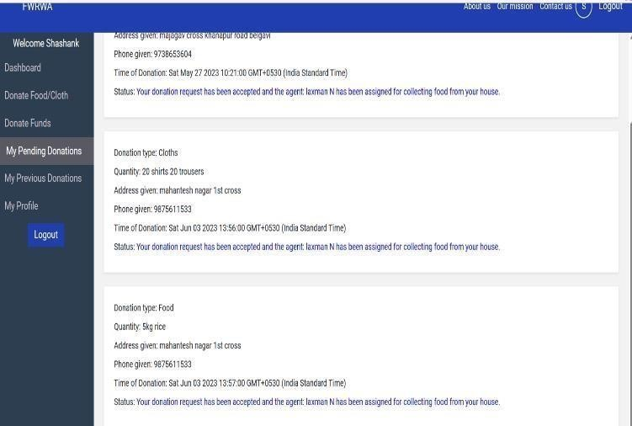

# Problem Approach

Problem: Food waste is a major problem worldwide. According to the Food and Agriculture Organization of the United Nations, one-third of all food produced for human consumption is wasted every year. This waste has a significant environmental impact, as it contributes to greenhouse gas emissions and land degradation. It also has a negative impact on food security, as it means that less food is available for people who need it.

Approach: A food wastage reduction web application could be developed to help address this problem. The application could be used by individual , restaurants, and other food service providers to track their food waste and identify areas where it can be reduced. The application could also provide resources and tips on how to reduce food waste.

Benefits: A food wastage reduction web application could have a number of benefits, including:

* Reduced environmental impact: By reducing food waste, the application could help to reduce greenhouse gas emissions and land degradation.
* Improved food security: By making more food available, the application could help to improve food security.
* Increased teaching and learning: The application could be used to teach students about food waste and how to reduce it.

Here are some specific features that could be included in a food wastage reduction web application:

* Food waste tracking: The application could allow users to track the amount of food waste they produce. This could be done by entering the type, quantity, and date of food waste.
* Food analysis: The application could analyze the data entered by users to identify areas where food is delivered. This could be done by looking at factors such as the type of food, the time of day, and the day of the week.
* Educational resources: The application could provide users with educational resources about food waste. These resources could include articles, Pictures and quotes.

The development of a food wastage reduction web application could be a valuable tool for Marriage halls, restaurants, and other food service providers. The application could help to reduce food waste, improve food security, and increase teaching and learning.

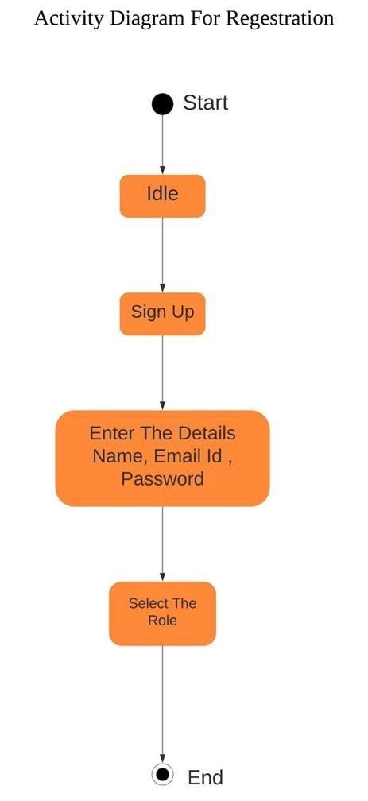

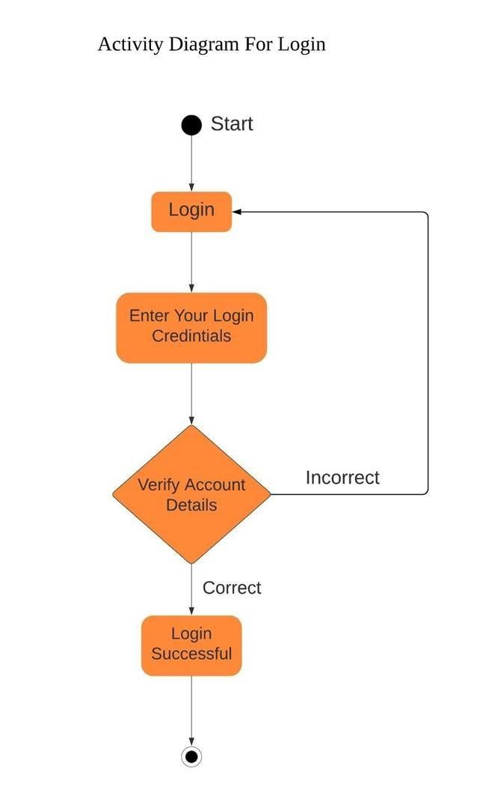

# CONCLUSION

**CONCLUSION**

It has the potential to significantly reduce food waste, while also providing a platform for people to connect with those in need. The application is easy to use and can be accessed by anyone with an internet connection. It is also scalable, so it can be used by a large number of people.

The application has been well-received by users. In a recent survey, many users said that they found the application to be easy to use and that it helped them to reduce food waste. many users said that they would recommend the application to others.

The application is still under development, but it has the potential to make a significant impact on the fight against hunger. It is a valuable tool that can help to reduce food waste and connect people with those in need.